|  |
| --- |
| stovetop games |
| Code Compiler |
| **Crowd sourcing code compiling since 1984** |
| Version #01  All work Copyright © 2012 by Stovetop Games.  All rights reserved. |
| **Aaron Fernandes (300773526)** |
|  |

|  |
| --- |
| September 24th 2016 |

# Table of Contents

Contents

Table of Contents 2

Version History 3

Game Overview 4

Game Play Mechanics 4

Camera 4

Controls 4

Interface Sketch 5

Menu and Screen Descriptions 5

Characters 7

Items 7

Scoring 7

Sound Index 7

Art / Multimedia Index 8

# Version History

**GitHub Repo:** <https://github.com/aagavin/sidescrollergame>

**Git Log:**

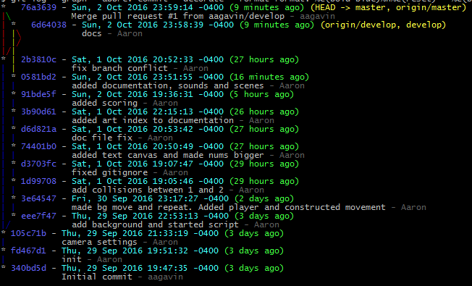

# Game Overview

Here are stovetop games we created a service to compile python code in the cloud. The service became so overloaded that our servers couldn’t handle it. We worked 5 ½ days straight to try and come up with a solution that would be fast and economical at the same time, until Jeff one of our engineers came up with the idea of have the code compiled trough crowdsourcing. This is where code compiler was created.

# Game Play Mechanics

The player uses the mouse to move the ship to collect 1’s and 0’s and tries to avoid the 2’s

# Camera

The camera is an Orthographic projection camera

# Controls

The mouse will be used for both movement and player firing

# Interface Sketch

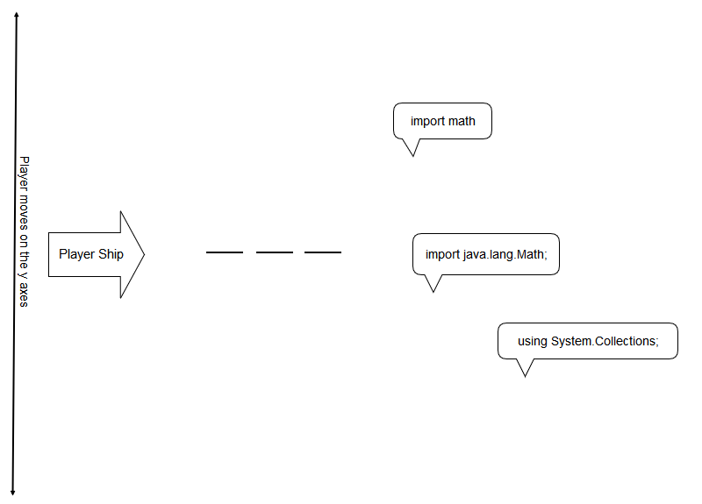Note: This was the original idea but the idea has changed since.

# Menu and Screen Descriptions

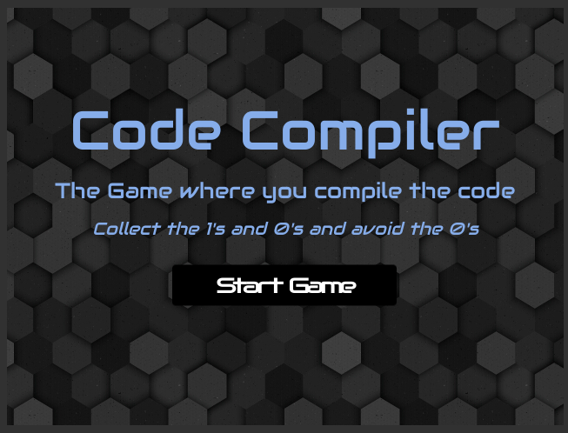

This is the menu scene that shows when a user starts the game.

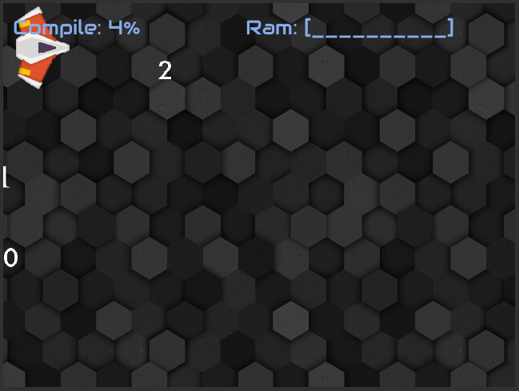  
This is the game play scene

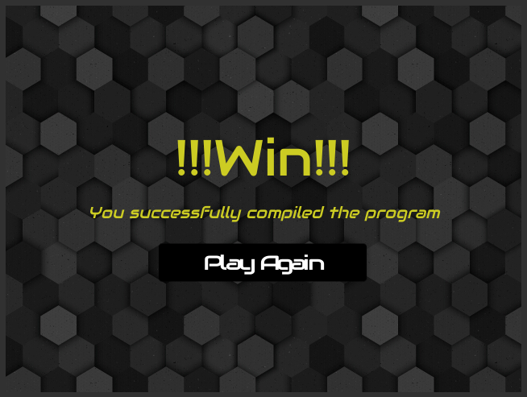  
 This is the Win scene. The user sees this when the compiler % goes to 100%

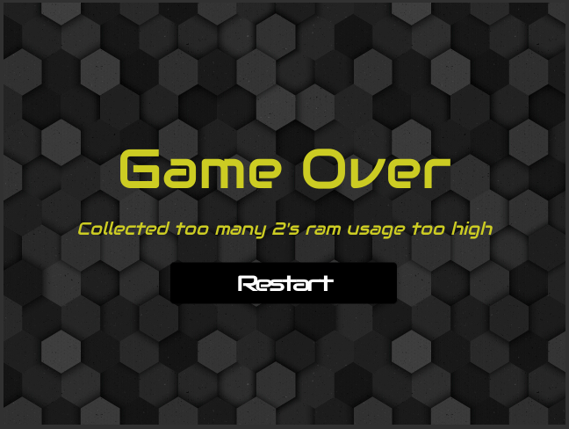

This is what the user sees when they collect 10 2’s.

# Characters

The player’s avatar is a space that flies over the ocean. The player can only move up and down

# Items

Player can collect 1’s or 2’s for points

# Scoring

When the user collects 0’s and 1’s the compile % goes up. When the user collects 2’s the ram bar goes up. The player can win by getting the compile % to 100% or they can loose by filling the ram bar

# Sound Index

|  |  |
| --- | --- |
| **Name** | **Use** |
| Artificial-beep | When a user hits a 2 |
| Coin-collect | When a user hits a 1 or a 0 |
| Program-open | When the game scene starts |
| Roadrollerbeat | Game theme sound |

# Art / Multimedia Index

|  |  |  |
| --- | --- | --- |
| **Name** | **Image** | **Source** |
| 0 |  | http://www.printablee.com/postpic/2012/09/large-printable-numbers-0-10_223476.jpg |
| 1 |  | http://www.drodd.com/images15/1-22.png |
| 2 |  | http://cliparts.co/cliparts/8c6/5ao/8c65aodgi.jpg |
| Background |  | http://bit.ly/2dAu7hQ |
| player |  | https://kharma.unity3d.com/en/#!/content/20749 |